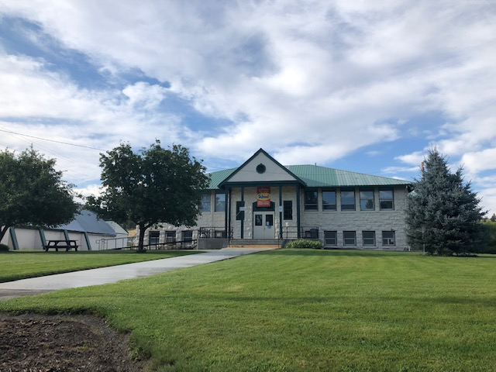

***Stay Connected***

***With Us >>>***



***“I never realized how much I enjoyed being at school until I wasn’t able to come.”***

***~Monument High School Student~***

* [*www.monumentschool.com*](http://www.monumentschool.com)
* *Follow us on Facebook at Monument School Tigers*

With school districts in Oregon forced to shift to “Distance Learning for All” to finish the 2019-2020 school year it was a huge sigh of relief for everyone when it was determined that Monument would be able to open for in-person instruction for the 2020-2021 school year.

To help meet the needs of families wanting to return to in-person instruction while also meeting the needs of those who did not want their students to return for in-person instruction, families were provided with two options to receive their education through Monument School District this year…In-Person Instruction or Comprehensive Distance Learning.

We currently have about 4% of our students who opted for Comprehensive Distance Learning. Families who are utilizing distance learning are engaged daily in all subjects, just as they would at school. They view live lessons with an Oregon certified teacher, complete assignments, take tests, and are assessed; all through the program Pearson-Conexus. The students are also engaged with their teacher and classmates who are on-site daily at Monument.

For families who chose on-site instruction, school looks much like normal with a few changes to ensure guidance compliance and the health and safety of everyone. Each morning, upon entry, everyone is screened to ensure they do not have symptoms of any illness. Staff and students are required to wear a face covering and floor markings are used to help remember physical distancing to the maximum extent possible. Classroom desks and the lunch tables are spaced to provide at least 6 feet physical distancing between students. Our cleaning and sanitizing practices have been increased and are completed multiple times each day along with a deep clean/sanitize/disinfect being done after students and staff have left the building for the day.

The staff and students have been amazing; easily adjusting to the new requirements. Everyone simply seems to be happy to be back in person learning together in the same space.

*Monument School Newsletter*

*Back In The Classroom!*

**Fall 2020**

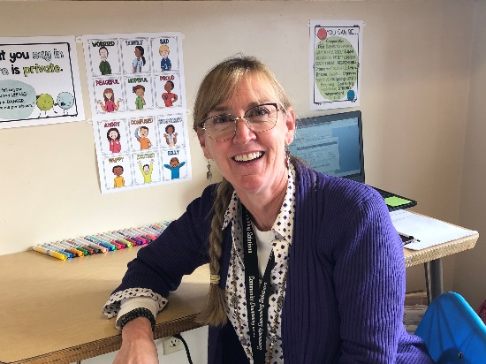

In May of 2020, the district was awarded a $2.45 million grant through Oregon’s Seismic Rehabilitation Grant Program To complete a seismic retrofit to the elementary building and the gymnasium. We have recently hired an engineering firm out of Oregon City, ZCS Engineering and Architecture, to work with us throughout the project. We will spend the school year designing, planning, and making all the appropriate preparations to be able to begin the construction on the two buildings as soon as students leave school for summer break. The plan is for the construction to be completed during summer break and ready for staff and students to return in the fall of 2021.

*Seismic Rehabilitaiton Grant*

Snack is served each day in the elementary to help keep the kids fueled throughout the day; this is provided by donation. If you have something you would like to donate for a healthy morning snack please contact the office or the classroom teachers.

*Lunch Program*

With COVID we were forced to adjust our breakfast and lunch service. Each day a delicious hot meal is still served to the students but we are notably missing the cafeteria’s great salad bar. This year students who have hot lunch will receive a tray that has all the offerings for the meal. As always, they are welcome to come back for seconds. While it is a little different than in the past it is always a great meal.

Due to COVID 19 pandemic, the United States Department of Agriculture (USDA) is extending nationwide waivers to continue serving nutritious meals for all students.  Monument School will operate under the National School Lunch Program Seamless Summer Option (SSO) and will provide meals (breakfast and lunch) to all students “at no charge.” SSO will be back dated to the first day of school (August 24, 2020) and payments made for this school year (2020-2021) will be refunded.

All outstanding accounts from the 2019-2020 school year, still need to be paid.

There is a new face to the river bus route this year; Ally Muhleman! Ally enjoys being a school bus driver because it is a challenge that she is successful at. “Not many young adults are qualified to safely operate a school bus while ensuring students behave while driving safely! As someone who grew up in a small community she is excited to be a part of the school which is always the center of the community. Ally previously drove bus for North Wasco School District and we are happy to have her a part of our Monument family! Make sure to wave hi when you see her each morning and afternoon during her route.

We would also like to welcome Sarah Welton as a part of our school family this year. Sarah has spent most of her career engaged with youth as a residential therapist, in schools teaching coping strategies against bullying, with special education students with severe emotional issues, as a classroom assistant, and even a substitute. Sarah understands that one size does not fit all and loves figuring out how she can best meet each person’s unique needs and helping them be the best version of themselves. In Sarah’s short time she has spent with our students, she finds them delightful and a joy to work with. For the 2020-2021 school year the district decided to increase a counselor’s presence in the school to once a week to help ensure the mental health needs of our students are being met. Each Monday when Sarah is here she meets with students individually, works in the classrooms on group lessons surrounding character skills, and is supporting the staff and students in any way that is needed. If you happen to see her make sure to stop and introduce yourself and say hi!

*New Faces to Monument*

Each school day Shawnah emails out a Bulletin with information for the day/week. If you are not on this list and would like to be please contact her to get your email address added.

*Daily Bulletin*

*Reminder...*

If your student is going to go somewhere different than they normally do at the end of the day please make those plans ahead of time and send your child to school with a note. We understand emergencies happens and occasionally plans need to change at the last minute but the end of the school day can be busy and chaotic and it causes much less confusion when notes are sent to school with the student.

*Updated Face Coverings and Shields Guidance From ODE…*

On Friday, October 30th ODE released updated guidance regarding face coverings/shields. All staff and students are still required to wear a face covering inside but also outside at school. Face shields are now only an alternative when a person has a medical condition that prevents them from wearing a mask or face covering. Staff will be able to wear a face shield at points in time if it is necessary for students to see mouth and tongue motions or vice versa.

Missoula Children’s Theatre has been a highlight of each school year for many years. Unfortunately, due to the COVID pandemic, MCT is not able to facilitate a residency as we had scheduled in early November. We are working with them to reschedule and host MCT at the earliest possibility this year.

*Missoula Chilren’s Theatre*

For more than 25 years Monument has operated a preschool for 3 and 4 year olds, free of charge. This is something that is a vital part of our school community. Over the years preschool numbers have fluctuated from as low as three or four students up to eight or nine students. We started the school year with 10 students enrolled and shortly after the start of the year we enrolled two new preschool students; putting us at a very exciting enrollment number of twelve students!

With this type of enrollment numbers, we had to look at a shift in the preschool schedule due to Early Learning (preschool) state requirements of a teacher to student ratio of 1:10. The district looked at multiple options including morning and afternoon groups, adding an additional staff member into the classroom, and serving only students slated to enter kindergarten the following year. After much consideration of student needs, research of other preschool programs, Early Learning Division COVID-19 Reopening Guidance, and discussion between administration, the preschool teacher, and consulting the certified staff, it was determined the best solution to be able to continue serving all students was splitting them into two groups with each group being served two days a week. While this lessens the amount of time our preschool students are at school, the progress made and lessons taught at school have stayed on track as if the students were here four days a week. With smaller group sizes and less variance on ability levels in each group more progress is able to be made in a single day.

While the district understands this was an unexpected change and may have caused some challenges for families to overcome with the schedule change, we believe this was the best academic decision for our preschool students while allowing us to continue serving all preschool age students who wish to be a part of our district.

*Increase In Preschool Enrollment*

*When to Stay Home from School*

* What’s the coolest thing that happened today?
* Pretend you’re the teacher. How would you describe the day?
* What made you laugh today?
* What was the most creative thing you did?
* How were you kind or helpful today? How was someone kind or helpful to you?

*Questions to Ask Your Student…*

While it is not required to get your work until you return from being home sick, we understand that some families wish for the parents to pick up their student’s homework or have their siblings bring it home.

If you would like your child’s work please contact the office in the morning so the teachers can find time to prepare the work to be picked up/send home by the end of the day.

*Homework When You Stay   
Home Sick*

It has always been important for staff and students to stay home from school when they are ill to help them recover more quickly but also to help prevent the spread to others. With the current COVID pandemic it is even more critical with some guidelines being more stringent.

Students/staff should stay home if…or students/staff will be sent home if…

* **Cough**
* **Diarrhea**
* **Fever**
* **Jaundice**
* **Lice**(live bugs)
* **Unknown Rash**
* **Skin lesions or drainage** (that cannot be contained within a bandage)
* **Stiff Neck/Headache with accompanying fever**
* **Strep throat** (May return after 24 hours on antibiotics)
* **Vomiting**
* **Colored drainage (any color that is not clear) from the eyes, ears, nose, mouth or any part of the body**
* **Other Symptoms or complaints** that prevent the student from participating in his/her usual school activities. An example: your student is lethargic and complaining that they do not feel good.
* **Symptoms specific to Coronavirus:** cough, fever or chills, shortness of breath, difficulty breathing, muscle pain, headache, sore throat, new loss of taste or smell, diarrhea, nausea, vomiting, nasal congestion, and runny nose.

A person should stay home until their temperature is below 100.4 F (orally) for a minimum of 24 hours without use of fever-reducing medication, when symptoms are resolved, or a doctor approves their return to school in the case of a known or suspected communicable disease.  (Examples of communicable diseases: strep throat, chickenpox, shingles, herpes simplex, hepatitis A, impetigo, fungus skin infections, head lice, hand, foot and mouth disease, scabies, reddened eye with thick mucus or pus draining from it, conjunctivitis, etc.)  When a child is diagnosed with such a disease, the school health office should be alerted.

Any student/staff who has knowingly been exposed to COVID-19 within the preceding 14 days is required to remain home from school until the 14 days post exposure has occurred and they are showing no symptoms along with notifying the school district.

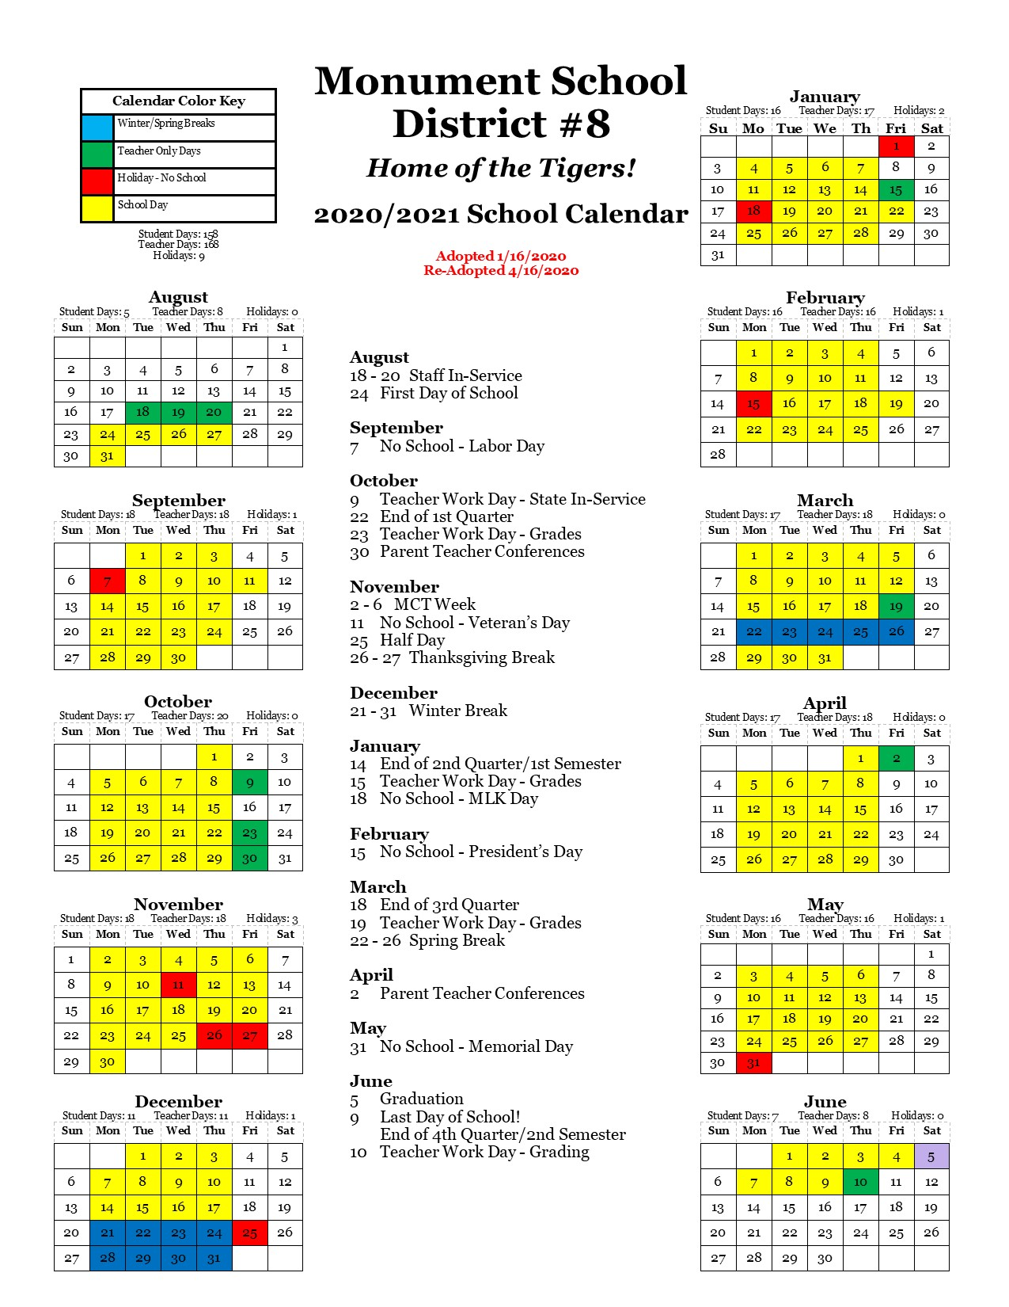

*It’s Beginning to Look A Lot Like Fall…*

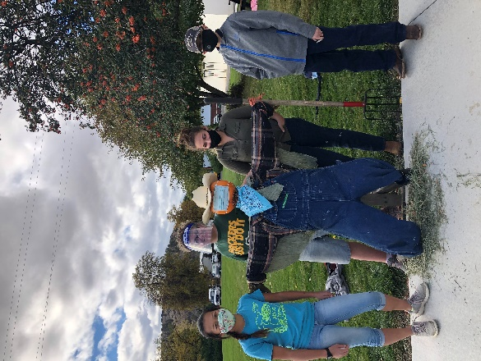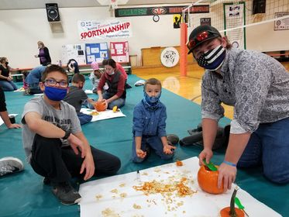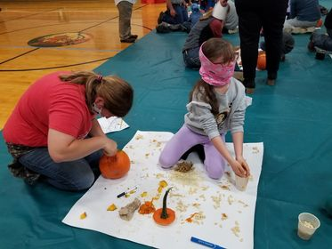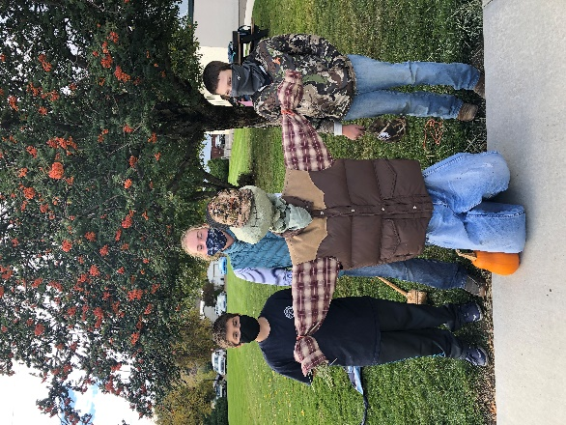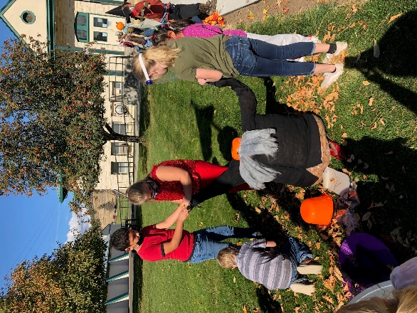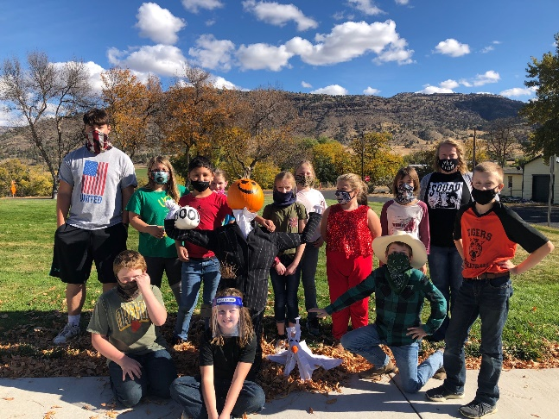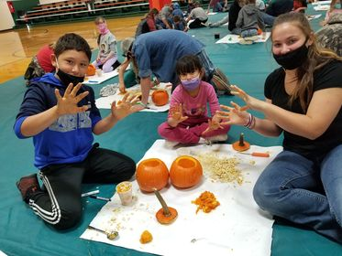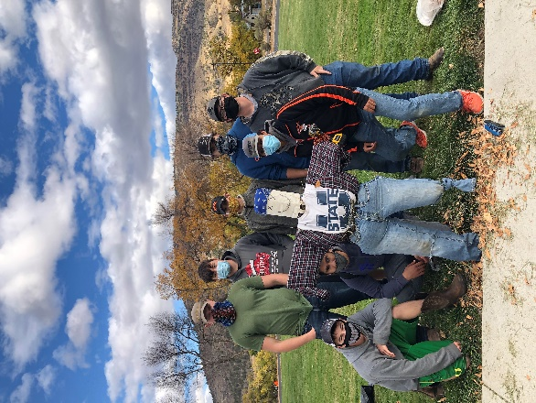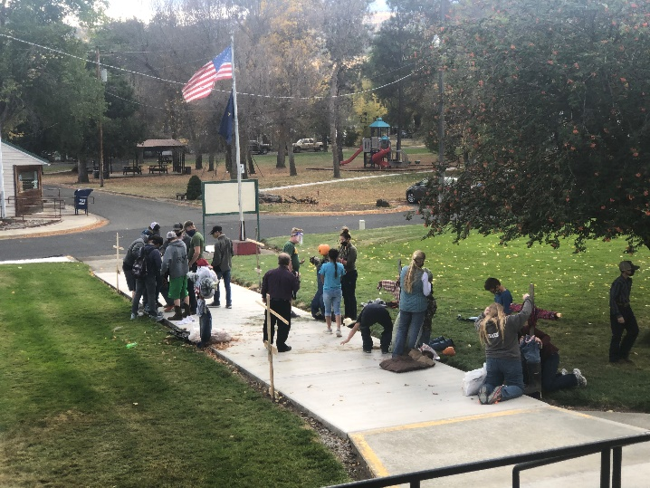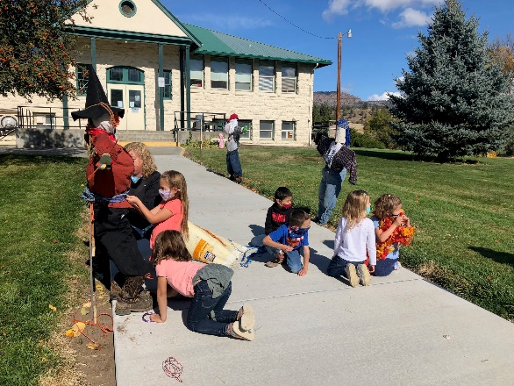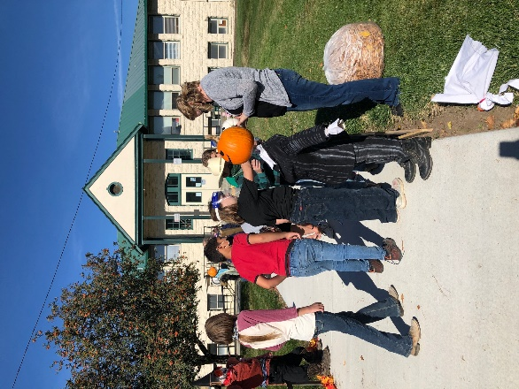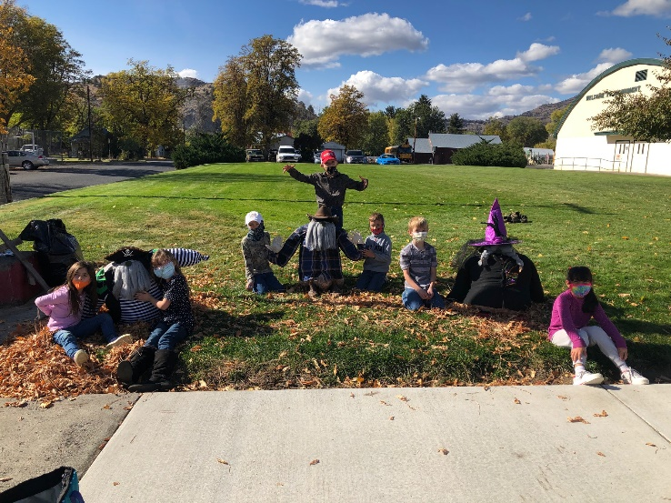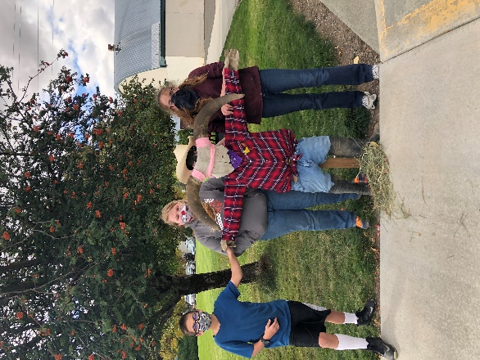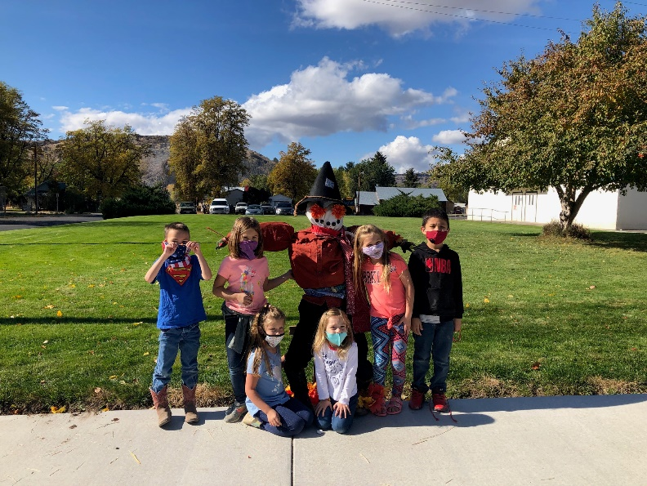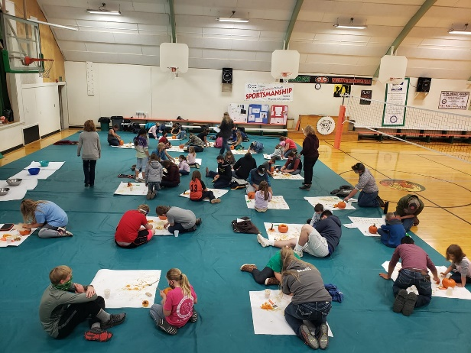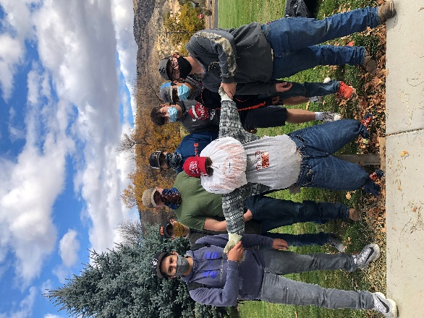

In the fall of 2019 the district spent time engaging with the students, staff, and community as the district planned for the additional funding from the Student Investment Account beginning in the 2020-2021 school year. Initial predictions for our funding level was around $95,000 for the year. The SIA is funded in part by the Corporate Activity Tax, which came in lower than projected, partially due to the COVID pandemic and the economic impact.

Districts across the state ended up receiving about a 1/3 of what was initially projected. Though the funding level is less the district still plans on working towards our same objectives, just with less funding.

The district set objectives of:

1. Improving Student Outcomes in Mathematics
2. All Students’ Social and Emotional Needs Are Supported.

In working towards achieving these objectives, some of things the district has incorporated or are working towards this year are:

* Response to Instruction time/services provided by a certified teacher
* Additional staff to help students in math
* Services for English Language Learners provided by certified teacher
* Daily snacks provided by the district
* Expanded presence of a school counselor

*OSAA 4 Season Plan for 2020/2021 School Year*

**Season 1**

**Aug. 31st – Dec. 27th**

* No OSAA set/regulated sports/contests

**Season 2**

**Dec. 28th – Mar. 7th**

* Basketball

**Season 3**

**Feb. 22nd – May 2nd (May 9th for football)**

* Football
* Volleyball
* Cross Country

**Season 4**

**Apr. 19th – Jun. 27th**

* Track

*Sports Workouts*

Sports play an important role in many students’ lives. With OSAA’s delay of the fall sports seasons, they ended up creating 4 seasons for the 2020-2021 school year. As a new season approaches OSAA will make determinations and release guidance regarding that season and it’s associated sports.

During season 1, some coaches have volunteered to hold voluntary workouts for any Monument 9th – 12th grade student. All students are encouraged to come to any and all workouts regardless if the coach hosting that day is the student’s coach or not. They will work on conditioning, skills, and drills. With football and basketball still on the Governor’s prohibited list, there is no scrimmaging. All eligibility and school guidance will strictly be enforced with the workouts. While the workouts are voluntary, it is expected that if a student comes to a workout they will arrive on time for the start and stay through the end of that workout, while putting in their best effort. Students also need to make sure their sports physicals are up to date to participate. Please contact the office if you are unsure of your last physical.

Because the workouts are voluntary and not part of an official sports season, all families are responsible for their own transportation home after each workout. Each workout will run from 3:30pm – 5:00pm.

We have brought back homework club! Homework Club is from 3:30 – 4:30 each day after school. It is an opportunity for students to sit in a classroom and work on homework and get help from the teacher on duty if they need.

* Monday – Ms. Cade
* Tuesday – Mrs. Hudson
* Wednesday – Mrs. Osborne
* Thursday – Mr. Metts

Despite some days Homework Club being in the elementary school and some in the high school, all students K-12 are encouraged to attend to work on their school work or any homework they may have each day.

*Homework Club*

*Student Investment Account*

*Show Your Tiger*

***P.R.I.D.E.!***

We truly have the best students, staff, parents, and community in our district and we are excited to see the students, staff, parents, and community show their PRIDE throughout the school year!

Participation

Respect

Integrity

Determination

Excellence

Each Thusday is Tiger Pride Day (or Fridays when there is Friday School)…wear your Tiger gear to show your Tiger PRIDE!

PRSRT STD

ECRWSS

U.S. POSTAGE

**PAID**

EDDM RETAIL

Monument School District

PO Box 127

Monument, OR 97864

(541) 934-2646

Local Postal Customer

Monument, OR 97864